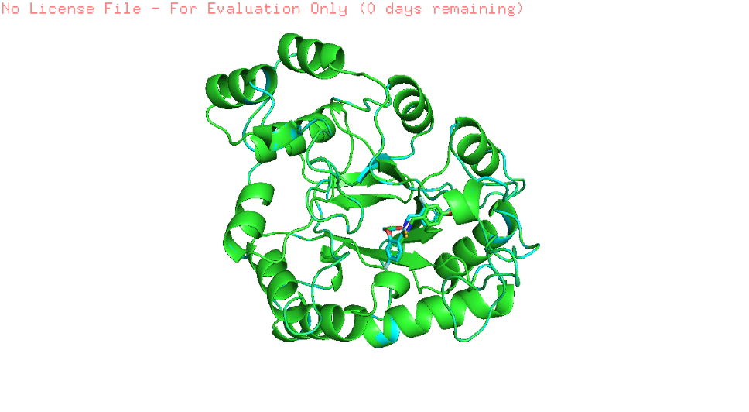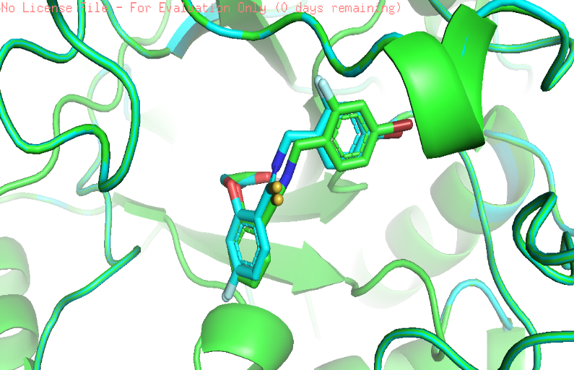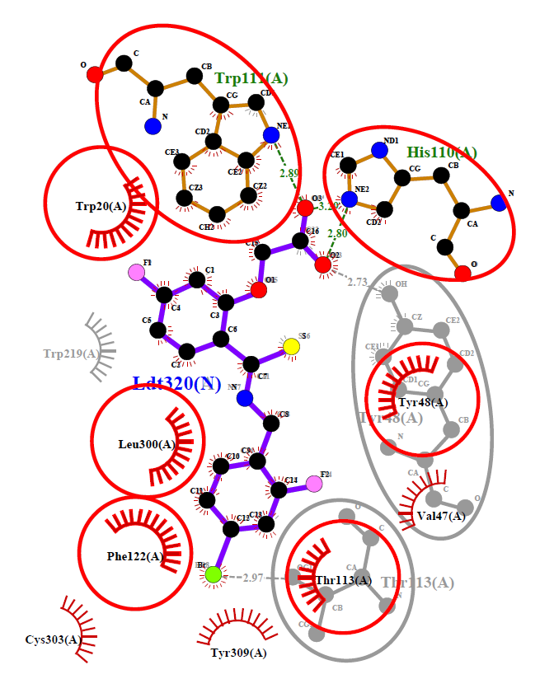

**(a)                                                                                 (b)**

**Validation of docking protocol by superimposition** **(a)**Superimposed image showing the structural alignment of the docked complex of native IDD594 ligand (green) and re-docked ligand (blue) in with protein representent in cartoon and ligand represented in sticks.  **(b)**LigPlot+ of superimposition between the co-crystallized ligand of aldose reductase (1US0) and the re-docked IDD594 ligand. Red circles represent the superimposed molecular interactions between both the co-crystallized and the re-docked ligands.